How can we Minimise the Risks from Earthquakes and Volcanos?
Natural hazards have the potential to destroy millions of lives, obliterating families, communities and causing significant economic damage. At present, an estimated 800 million people live within a dangerous 100km of an active volcano. Earthquakes threaten millions more, and so can cause huge numbers of deaths in a single quake, for example the death toll of 220,000 caused from the Haiti earthquake in 2010. With so many millions of lives at risk and an exponentially growing population, the importance of prediction, preparation and protection is vital to reduce the potential catastrophe that natural hazards pose.
But what makes earthquakes and volcanos so risky in the first place?
Earthquakes. Firstly, ground shaking and displacement causes the most damage, mainly because structures cannot withstand the shaking, particularly the motion caused by surface waves. Economically, this displacement is extremely damaging, but more importantly many lives are inevitably lost. Furthermore, pipelines, sewers, roads and rigid structures (for example railway tracks) are often ripped apart. Natural drainage systems can also be altered, influencing rivers, streams and groundwater in aquifers, hence impacting irrigation, agriculture and public water supplies. Liquefaction, landslides and avalanches are further risks posed by earthquakes. In addition, tsunamis are triggered by underwater earthquakes: a quake causes a column of water to be displaced vertically, which spreads from the epicentre at a high velocity and with an extremely long wavelength is: up to 200km. The effects are devastating – take, for example, the 2004 Indian Ocean tsunami which caused 230 000 deaths, and left around 2 million homeless.
Volcanos. One of the many risks of volcanic eruptions is the lava flow. At temperatures of around 1000° C, lava destroys almost all it touches, damaging infrastructure and agriculture. Basaltic lava, for example, can flow for significant distances (in some cases 20km), damaging large areas. Tephra (material ejected from volcano to air), including ‘volcanic bombs’ and ash can bury farmland, decrease food production, disrupt transport (particularly flights), cause difficulty breathing and cover buildings, leading to their collapse. Furthermore, toxic gases emitted pollute the surrounding environment and can jeopardise human health. Pyroclastic flows (superheated gases, ash and rock fragments), like lava instantly cause destruction and death, whilst fast moving lahars (mud flow, often triggered by the heat melting ice and snow - as floods often are) destroy everything in their path. Even tsunamis can be activated by underwater volcanos.
It is therefore vital to minimise the risks from these natural hazards, given the destruction which they cause.
The disaster risk equation – covers both earthquakes and volcanos and gives us an indication of the degree of risk from a natural hazard associated with a particular location.
R = H x V jk jjC
Risk (R) = Frequency or magnitude of hazard (H) x Level of vulnerability (V) Capacity of population to cope and adapt (C)
As shown, magnitude and frequency of the event increases risk, in addition to high levels of vulnerability. However, if a population can cope and adapt to the situation, risk is reduced. Therefore, it is critical (in fact, it is as important as the geophysical event itself in many circumstances) to equip vulnerable people with methods of coping and adapting in order to reduce risk, as well as reducing their vulnerability in the first place.

Causes of earthquakes and volcanos
Earthquakes. Convection currents in the mantle cause tectonic plates to move – around 95% of all earthquakes occur at plate boundaries. Strain because of this tectonic movement causes deformation at plate boundaries, but friction means that the faults don’t slip continuously. The deformation results in the build-up of stored elastic energy, which, when a threshold is exceeded, is released as the fault ‘segment’ slips, causing an earthquake. This is known as the elastic rebound theory, discovered by H.F. Reid in 1910. The release of energy sends a series of shock waves from the earthquake’s focus:
Primary (P) waves: longitudinal waves with a low frequency and high velocity. These waves cause little damage, since they have relatively small amplitudes. Intensity ∝ (amplitude)², so the rate of flow of energy per unit area is smaller.
Secondary (S) waves: transverse, high frequency waves which travel at around half the speed of P waves, arriving at the detector of a seismometer second. Despite this, S waves cause more damage due to their greater amplitude and the fact that they cause both vertical and horizontal motion.
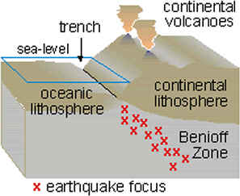
Surface (L) waves: both low frequency and velocity. These mechanical waves can only travel through the outer crust. Having a greater amplitude (a few centimetres in large earthquakes), it is this type of wave which causes the most damage: their slow rolling motion just beneath the surface generates the biggest risk of destruction to man-made structures and also changes in landforms.

Volcanos - they occur at both convergent and constructive plate boundaries. The risk to human populations is higher with volcanos at convergent plate boundaries, as these are generally on land, whereas constructive plate boundaries usually occur under the sea.
At convergent oceanic-continental plate boundaries, the oceanic crust subducts beneath the continental crust (at an angle between 30 and 70°) since it’s more dense. In the Benioff zone (see diagram), faulting and fracturing occur, causing earthquakes. Enormous amounts of friction between the crusts (and also heat from the mantle) causes the partial melting of the basaltic crust, creating plutons of magma which rise – as it’s less dense than surrounding crust - through vents ultimately causing the volcano.

What are the methods of reducing risk for earthquakes?
1) Hazard resistant building design. Aseismic design – engineering and architecture designed to endure displacement and seismic activity – is often used as a key method in minimising damage triggered by earthquakes. Seismologists have often said that ‘earthquakes don't kill people, buildings do’, so aseismic design is increasingly important.
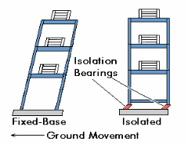
a) Base isolators use inertia – ‘the tendency to remain unchanged’ and Newton’s First Law. Normally, buildings remain stationary because the forces acting on them are balanced. However, during an earthquake, the base of the building moves, whilst the upper part wants to remain stationary because of its inertia. This puts substantial strain on many parts of the building, risking a collapse. Engineers use the inertia of buildings to their advantage, to prevent the buildings from collapsing. The principle is to allow the building to be unaffected by the movement of the ground: the isolation bearings move instead of the entire building. The inevitable oscillations of the building are decreased by friction of the isolation bearing pads, which also encourages the building to return to its original position. Moreover, the friction reduces the impact on the structure overall, since it dissipates kinetic energy from the quake (into heat energy), meaning less energy is transferred to the building, so less shaking and overall damage (Coulomb damping). In particular, it’s the horizontal energy from an earthquake that’s prevented from being transmitted to the building. A good example of a base isolated building is the Los Angeles City Hall.

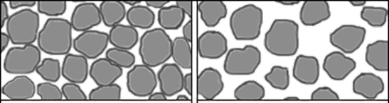
b) Deep foundations also minimise the effects and so the initial risk of an earthquake by preventing the consequences of liquefaction, especially on loose, granular, saturated soils. Overall, liquefaction is a major contributor to urban seismic risk, and its consequences can be devastating: the ground temporarily loses its bearing strength and so can no longer support buildings, therefore structures are prone to collapse.
Liquefaction
Normal pressure
Under normal pressure, softer sands maintain strength due to the friction between touching particles, despite often being saturated. However, force from earthquake waves (cyclic loading) causes the pressure to suddenly increase, overcoming the friction of the particles. Consequently, the water will fill the pore spaces, triggering the ground to act as a fluid. This occurs ‘when the effective stress of soil is reduced to essentially zero’, so there’s also a total loss of shear strength.
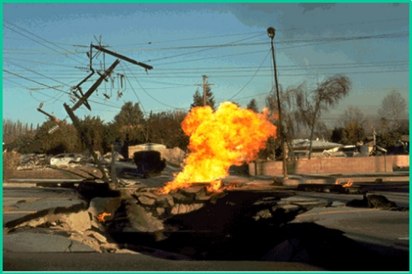
Effects of liquefaction (in addition to loss of bearing strength) include: lateral spreading, ground oscillation, sand boils, flotation and flow failure. Figure 1 illustrates how lateral spread caused a gas main to be ruptured in Granada Hills during the 1994 Northridge earthquake.
Figure 1
Deep foundations, often down to the bedrock, mean that the ground which the buildings directly rest on is stronger, less granular and generally cannot become saturated. Hence the particles never become isolated in water under pressure, and so liquefaction does not occur. Moreover, deep foundations allow the building to move without collapsing, and provide general stability. Here, something so simple as deep foundations can have a dramatic impact on potential risk.
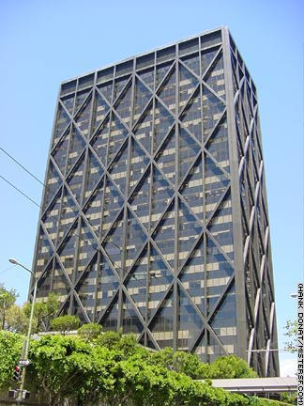
In addition to using deep foundations, liquefaction susceptibility maps have been produced by the USGS, which have been used by, for example, land use planners to decrease the risk of what is often considered as one of the main sources of earthquake induced catastrophes.

c) Cross braced and steel framed buildings allow considerable energy from the quake to be absorbed when the building deforms. Thus, a building’s ability to resist seismic forces is increased, reducing the chance of collapsing and so risk to people inside.

Other key methods of preparation include training emergency services, organising supplies, planning, practicing drills and evacuating.

2) Monitoring. Monitoring is an extremely important method of reducing risk, as it allows the forthcoming seismic activity to be predicted in advance, so people can evacuate or brace themselves, which would inevitably reduce impacts of the quake.
Sensitive seismographs record ground motion from seismic waves produced by earthquakes. Vibrations from the earth cause the instrument to move, so the relative motion between the mass and the rest of the instrument is measured by the line produced on the paper, hence recording the ground motion. An increase in seismic activity can indicate a imminent earthquake.
Seismogram
However, the seismic gap approch is also used: lower levels of seismic activity compared to relatively nearby plate boundaries can indicate a build up of pressure and tension, signifying an approaching earthquake. Before the October 1989 earthquake in Loma Prieta, California, there were numerous gaps in seismic activity, allowing the quake to be predicted. The figure below shows activity from January 1969 to July 1989, with an obvious gap in seismic activity before the event.
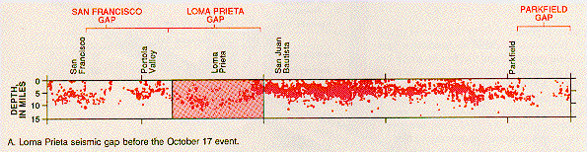
Another method of monitoring is measuring levels of radon gas: it escapes from cracks in the earths crust, so a dramatic increase could indicate a forthcoming quake. Laser beams are also used, with both earthquakes and volcanos, to detect small surface movements: a laser beam is produced then reflected, and the time taken for it to return to the source is used to calculate distances extremely accurately. This crust movement often indicates natural disasters.

What are the methods of reducing risk for volcanos?
1)Changing lava flow. In some cases, a management strategy is in fact, to modify the actual event of the volcanic eruption. In the past, lava diversion channels have been created – often to save the vulnerable houses in the flowing lava’s pathway. This has been attempted as far back as 1669, where Sicilians created an ‘artificial beach’ against the lava flow from Mount Etna. More recently, barriers have been successfully used against the flow of lava from mount Etna, saving a major tourist area in 1983. Similarly, concrete blocks can be dropped to slow lava flow, and lava can be sprayed with water to make it solidify, preventing further advancement.
A technique used historically was to bomb lava tubes. These are solidified outer crusts of lava, which allow the accelerating molten lava inside them to be insulated, and so continue to flow. The initial idea was to destroy these, exposing more lava to the air. Here, the increased surface area to volume ratio would accelerate cooling, resulting in the solidification and so immobilisation of the molten rock.
Despite the advantages of changing lava flow, this method is extremely expensive and so generally a solution only available to more economically developed countries.
2) Monitoring. Changing lava flow is one of the only methods of reducing risk following an eruption, hence why monitoring is so important. Since humans can rarely survive for example the pyroclastic flows and lava of a volcano, prediction is vital for a population to prepare and protect themselves.
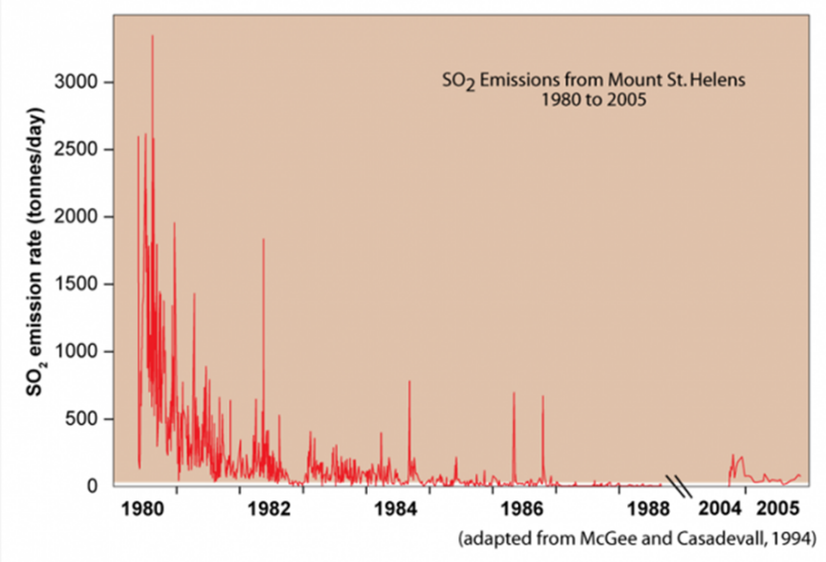
Compared to earthquakes, volcanos can be monitored relatively easily, so they are easier to predict and so people can then prepare, which obviously reduces the risks.
An increase in the amount of sulfur dioxide (SO₂) released indicates a volcano: this graph (left) shows how there’s a significant correlation between the eruption of Mt St Helens in 1980, and the SO₂ emissions. Often, the quantity of ultraviolet (UV) radiation absorbed by the volcanic gas plume is measured, which indicates the extent of the SO₂ emissions.
In addition, tiny earthquakes (measured by seismometers) are produced as magma rises through the earth’s crust – these are a critical indication of an imminent volcano. Moreover, change in surface temperatures are monitored by satellite images. This thermal infrared technology allows areas to be located where hot magma (meaning a possible approaching volcano) has reached the surface.
Likewise, change in shape of volcanos can indicate a bulging magma plume, so a forthcoming volcano: GPS and tiltmeters are used to monitor these changes, and have successfully predicted a volcano, for example the Mount St Helens eruption.

Overall, despite the catastrophes caused by earthquakes and volcanos, risks have been and can be minimised, and potentially even eliminated in the future with further research into monitoring techniques. With a global average population density of 57 people per km², it is crucial to decrease the risks of what are often considered as the most significant tragedies our population faces today.

Bibliography
- https://www.oxfam.org/en/haiti-earthquake-our-response
- Global volcanic hazards and risk GVM http://globalvolcanomodel.org/wp-content/uploads/2015/08/Global-Volcanic-Hazards-and-Risk-Full-book-low-res.pdf
- OCR A Level Geography textbook
- http://data.worldbank.org/indicator/EN.POP.DNST (world population density)
- https://geo.libretexts.org/LibreTexts/UCD_GEL_101%3A_Structural_Geology/Part_II%3A_Strain%2C_Rheology%2C_and_Tectonics/Global_Tectonic_Processes (Benioff zone diagram)
- http://www.bbc.co.uk/news/magazine-29136747 (BBC News article – stopping lava flow.)
- https://nees.org/resources/3832 (diagram and base isolators)
- https://en.oxforddictionaries.com/definition/inertia
- https://en.wikipedia.org/wiki/Coulomb_damping
- https://www.google.co.uk/search?q=cross+braced+building&source=lnms&tbm=isch&sa=X&ved=0ahUKEwjH2p6E86vSAhVnC8AKHb1oCdYQ_AUICCgB&biw=1366&bih=651#imgrc=Z1Xeq-HRkwrKJM (cross braced building photo)
- http://www.sms-tsunami-warning.com/pages/earthquake-effects#.WGeFv4XXLIU
- https://www.nature.nps.gov/geology/monitoring/files/geomon-10.pdf
- https://www.iris.edu/hq/inclass/animation/seismograph_vertical (seismograph diagram)
- http://www.bbc.co.uk/schools/gcsebitesize/geography/natural_hazards/managing_hazards_rev2.shtml (monitoring)
- http://sepwww.stanford.edu/oldsep/joe/fault_images/lpgap.html (seismic gap, California)
- https://volcanoes.usgs.gov/volcanoes/st_helens/st_helens_monitoring_104.html
- https://www2.usgs.gov/faq/node/3805 (SO₂ emissions)
- Seismic waves
  - http://www.iris.edu/hq/files/programs/education_and_outreach/aotm/6/SeismicWaveBehavior_Building.pdf
  - https://www.reference.com/science/seismic-wave-causes-damage-7b01b0eb10fa3e41#
  - Sammis CG, Henyey TL. Geophysics Field Measurements, page 12. Academic Press; 1987. (amplitude of surface waves)
- liquefaction
  - https://geomaps.wr.usgs.gov/sfgeo/liquefaction/aboutliq.html
  - https://www.britannica.com/science/soil-liquefaction
  - https://en.wikipedia.org/wiki/Soil_liquefaction
  - https://www.youtube.com/watch?v=DwJJqvHr3Yk
  - http://www.showme.net/~fkeller/quake/liquefaction.htm (the diagram)

