SYMMETRY ANd the laws of nature

Physics aims to establish a set of rules that describe nature precisely and completely. Existing laws have given us a glimpse of her beauty and simplicity, namely that reality is infallible, unyielding and astonishingly symmetric. But what is symmetry? Fundamentally, it is defined as ‘consistency under a tranformation’, like a butterfly fluttering in a world identical in every direction. We shall explore the importance of this principle through a chronology of scientific theory and evaluate its necessity in understanding the laws of nature.

SYMMETRY IN SPACE AND TIME
Simple yet profound, symmetry demands that physics doesn’t change under a translation in space or time – universal laws apply equally to Rome in 1989 as they would to Mars in 3050. In figure 1, Rafiki holds Simba x metres above the ground. If the cub has mass m, his gravitational potential energy is mgx. The force acting on Simba is the negative of the derivative of his potential energy with respect to his position, so F=$-\frac{d(mgx)}{dx}$ =-mg. If Rafiki climbs a hill, however, Simba’s potential energy increases by some constant, E to mgx+E. The force will now be$\left(-\frac{d\left(mgx\right)}{dx}\right)+\left(-\frac{d\left(E\right)}{dx}\right)$. As E is a constant, its derivative is zero and thus F=$\left(-\frac{d\left(mgx\right)}{dx}\right)-0$ =-mg, which is the same as at the bottom of the hill.

x m

x m

E
Figure 1: Rafiki lifts Simba above the ground

Furthermore, if Rafiki faced the other way, the force acting on Simba would not change. Thus the laws of nature are symmetric under rotations in space.
Inertia presents another space-time symmetry. Newton’s third law of motion states that an object will be in a state of inertia, stationary or travelling at a constant speed when there is no resultant force acting on it. Further, Galilean relativity suggests that physics is the same for any body in such an inertial reference frame.
Galileo believed, however, that time was absolute. Two and a half centuries after his death, Albert Einstein, accepting that time slows when travelling near the speed of light, made the laws of physics independent of acceleration. He wove space and time into a single entity and developed his theory of special relativity to show that ‘distances’ in space-time are identical to all observers. This theory was derived from a crucial symmetric axiom, suggested by Maxwell’s equations of electromagnetism – the speed of light is constant in nature.

CPt symmetry
Parity (P) symmetry states that laws of physics are also consistent under reflections in space. D-carvone and L-carvone are non-superimposable mirror images of one another. While chemically distinguishable, with L-carvone smelling like spearmint and D-carvone like caraway, physically, they are identical. For example, both rotate plane-polarised light by 61º.
Galileo believed time to be like a clock ticking somewhere separate from the universe. Physical laws are mathematically time reversible, however, dismantling Galileo’s ideology. This is T symmetry, in which we can replace t with –t and those laws are unchanged. The exception is the second law of thermodynamics, which states that the entropy of a system always increases. Perhaps time, then, is progression along an entropic gradient, by which the future is more uncertain than the past. Arguably, it only seems uncertain because we are unable to consider every particle in a system. If we could, would time appear reversible?
Experiments have shown, however, that P and T symmetries are violated in weak interactions. This helps to understand why anything can exist when matter and antimatter annihilate upon meeting. Differences in how matter and antimatter decay could explain why there is more matter in the universe. But even one exception necessitates we reject these theories as symmetries of nature, what Thomas Huxley would call ‘the slaying of a beautiful hypothesis by an ugly fact’.
That said, in 1900, Max Planck published a paper that marked the birth of quantum mechanics. It was the physicist Paul Dirac who attempted to consolidate this field with special relativity, writing an equation in 1928 to which there are always two solutions (just as $\sqrt{9}$ can be +3 or -3). This is explained by antimatter; for every particle there is an antiparticle with the same mass but opposite quantum charges e.g. opposite electric charge. A symmetry exists by which matter and antimatter are interchangeable - a car built entirely of antimatter particles will work just as well as a regular one. This is called charge (C) parity and can restore the symmetry of weak interactions. It is now hypothesised that if C,P and T are performed consecutively, the laws of nature remain do indeed remain symmetric.

The Standard Model
Dirac’s work also initiated quantum field theory (QFT), which sees the universe as a collection of fields, the excitations of which present themselves as the fundamental particles. In the 1970s, a theory combining 20th century developments in particle physics was built (figure 2). This is the standard model, which illustrates the relationships between the fundamental particles and the fundamental forces of nature (except gravity). There are two types of matter particle – quarks and leptons, which both have ½ integer spins. The lightest particles make up the first generation and the heaviest the third. There are then the gauge bosons, with integer spins, that are exchanged between matter particles to communicate the electromagnetic, weak and strong forces.
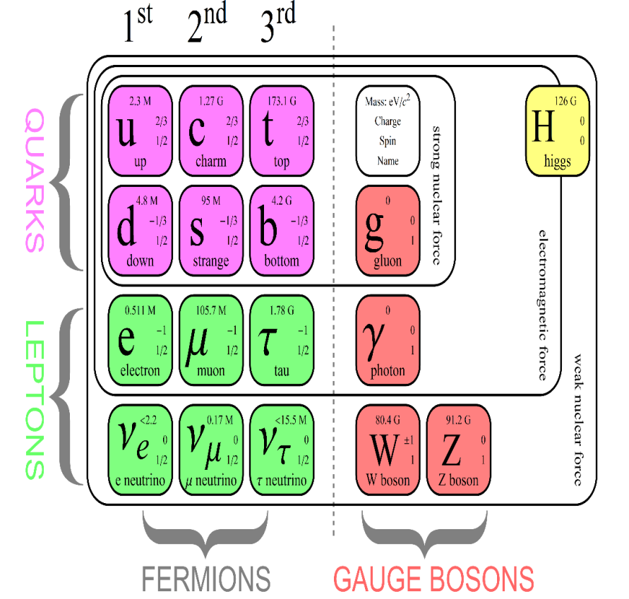
The wave function (Ψ) first appeared in the equations of Erwin Schrodinger. Finding the square of a particle’s wave function will give the probability of finding it at that position at that time. The probability density of a system containing two particles, p₁ and p₂ is thus denoted$\left|Ψ(p_{1},p_{2})\right|$². A symmetry within the standard model states fundamental particles of the same type are indistinguishable, therefore$\left|Ψ(p_{1},p_{2})\right|$²=$\left|Ψ(p_{2},p_{1})\right|$². There are two solutions to this equation. We get the symmetric caseΨ(p_{1,}p₂)= Ψ(p_{2,}p₁) when exchanging particles with integer or zero spin, these are classified as bosons. The asymmetric caseΨ(p_{1,}p₂)=-Ψ(p_{2,}p₁) is achieved with particles of half integer spin, which we call fermions. Zero is the only number that is a negative of itself so we see that the probability of two fermions occupying the same space is nothing. So, again, symmetry is integral to the standard model.
Figure 2: The standard model

gauge theories
Although gauge symmetry is rooted in the 19th century with the discovery of electromagnetism, it was the development of QFT that highlighted its importance. Some properties of particle fields, are measurable (e.g. the charge), whereas others (e.g. the phase) are not. A gauge theory is one in which there is a group of transformations that can be performed on a field, without changing its observable quantities.
Imagine freezing a satin scarf as it is being shaken in the air. We can use this as a model for an electron’s wave field; there is a high probability of finding the electron at a ‘hill’ and a low probability where there is a ‘dip’. If a watch is placed at each point of space-time on the scarf, the number of times the second hand passes twelve in a given time is called the frequency. The watches are not particularly well made, however, and they begin to slow. Thus, you may presume the electron’s state has changed as it now has a different frequency. Upon closer inspection, however, you see that the numbers on the watch face are also rotating. Every time the hand moves one forward, the numbers move one back, so the hand passes the twelve with the original frequency. This mystical force interfering with our numbers is called the gauge field. When we accelerate the electron, giving it more energy and thus changing its frequency, the gauge field manifests itself as a physical particle that is emitted from the electron, compensating for the change we have made. The system incorporating both particles thus remains invariant despite our transformation. This is gauge symmetry. I like to compare this to the ‘useless box game’ (figure 3). A switch is flicked, triggering a mechanical arm that flicks it back again, leaving the system unchanged.
Figure 3: ‘Useless box’
The gauge boson in the example above is a photon. It communicates the electromagnetic force. For example, a photon emitted by one electron and absorbed by another causes them to repel, as shown by the Feynman diagram in figure 4. This theory is called quantum electrodynamics.

Omega-minus is a subatomic particle composed of three strange quarks. We have seen, however, that identical fermions cannot occupy the same point in space. There must be something about these quarks, therefore, making them distingusishable. We call this colour, and there are three forms – red, blue and yellow. Quantum chromodynamics is a gauge theory concerning colour transformation. For example, a red quark can turn into a blue quark by the emission of a gauge boson called the gluon. The gluon will consist of a red quark and an antiblue quark. Blue and antiblue cancel out and thus the overal colour of the system is still red. The gluon confers the strong force, which holds particles in the nucleus together.
Figure 4: Feynman diagram of electron repulsion

A third gauge theory called quantum flavour dynamics explains the weak force. A neutron consists of two down quarks and an up quark (udd). One of the down quarks can change its ‘flavour’ to become an up quark by the emission of a W⁻ boson. This particle has a mass eighty times greater than the neutron. This extra mass is ‘borrowed’ in the form of energy from the vacuum. According to Heisenberg’s inequality, the product of the time and the energy must be less than the planck constant. The energy can thus only be borrowed for a very short time and the W⁻boson quickly decays into an electron and a neutrino. We now have a down quark and two up quarks, which is a proton. In this way, guage symmetries explain the forces between all particles and waves in the universe.

conservation laws
Now we have established some of the ways in which nature is symmetric, we must consider the consequences of her being so. In 1915, Emmy Noether proved that every physical symmetry bears a conservation law. Firstly, translational symmetry in space means that momentum is conserved. When Andy Murray hits a ball, the ball exerts a force on the racquet (F_{1,2}) and the racquet on the ball (F_{2,1}). Newton’s third law of motion states that every action has an equal and opposite reaction and thus F_{2,1}=-F_{1,2}. Impulse is the product of the force and time and because both forces act for the same amount of time, the impulse applied to the ball is therefore equal and opposite of that on the racquet. Newton’s second law states that a force on an object is the same as its rate of change of momentum(F=$\frac{d(mv)}{dt})$ and hence, impulse is equivalent to the change in momentum. The sum of the ball’s momentum and racquet’s momentum is consequently zero, the same as before the impact, so momentum is conserved. Furthermore, the conservation of energy results from symmetry under a translation in time and states that energy cannot be created or destroyed.
Thirdly, angular momentum is the amount of ‘drive’ an object has while moving in a circle. It is calculated by the product of the radius, mass and velocity. Angular momentum is always conserved due to the invariance of physical laws under a rotation in space. Imagine a ballerina who can pirouette infinitely, holding her arms sideways as she does so. If she retracts her arms, she will turn faster. This is because her radius has decreased so her velocity must increase to conserve her momentum. The ideas of conservation granted by symmetry have been key tools in solving many physical problems.

breaking symmetry
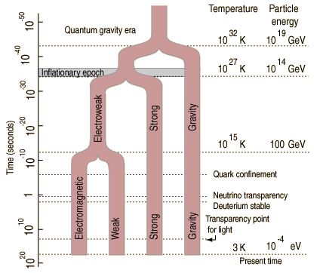
The destruction of symmetry is of equal importance. For example, a javelin balanced on its point, can fall at any angle, so the probability distribution is symmetric about the point. If the javelin is disturbed, however, it can only fall in one direction. We say the symmetry has been simultaneously broken.¹⁶
Spontaneous symmetry breaking (SSB) is seen with ferromagnetic materials. At high temperatures, there is rotational symmetry because the spins of the atoms are random. When the temperature is sufficiently low, however, their spins align, breaking the symmetry and creating a magnetic field. In another example of SSB, there was a single force immediately after the big bang. As the temperature cooled and entropy increased, the force spontaneously broke into the four fundamental forces we see now. (figure 5)
It is believed that particles are given mass by moving the Higgs field, which is spread through the universe. The potential energy of this field has a shape comparable to the bottom of a wine bottle (figure 6). If a bead is poised on the indent where the field value is zero, there is symmetry. This is unstable and easily broken, however, causing the bead to roll into the trough. It is now stable, but the field has a value, meaning it can interact with other fields. This interaction causes the bead to roll up and down the sides of the trough, and it is called the Higgs boson when it does so. On 4th July 2014, the Higgs boson was detected by the Large Hadron Collider (LHC) in Geneva.
Figure 5: There was originally one force that broke into the four fundamental forces we recognise now.

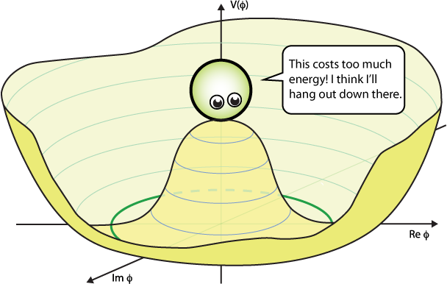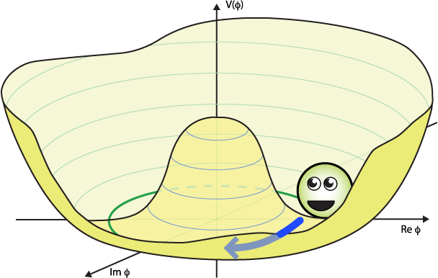
Figure 6: The Higgs field can be represented by a shape similar to the bottom of a wine bottle

The LHC, however, has been unable to prove another principle called supersymmetry (SUSY). SUSY suggests that for every fermion, there exists a supersymmetric boson, unifying force and matter. SUSY is an example of how symmetry could solve some of the mysteries of the universe. For example, dark matter could be the lightest of all supersymmetric particles, which only weakly interacts with other particles. We do not, however, have sensitive enough equipment to validate this yet.

THE NECESSITY OF SYMMETRY
Symmetry, particularly supersymmetry, has the potential to explain the universe beyond the ability of the standard model. Could this lead to the grand unification theory physicists yearn for? We must question whether the universe is fundamentally symmetric or whether this is a perception (It is proved that humans have symmetry bias and find symmetric faces more attractive.) Do we only demand symmetry of nature because it is easier to understand? Perhaps, but symmetry has been proved through objective experimentation: there have been no signs of CPT violation, the Higgs boson exists and in 2016, LIGO detected gravitational waves, the predictions of a theory built on symmetry. Yet symmetry is mathematical and thus dubious - is mathematics natural or invented?

So is symmetry a necessity in understanding the laws of nature? Symmetry provides a tool with which to simplify and understand the universe. In identifying symmetries, we have built news laws, such as Noether’s theorem. Conversely, other laws, such as Dirac’s equation have revealed the hidden symmetry of reality. Whether these patterns are real or our creation, there is no doubt they form the backbone of modern physics. Yet we have ignored the most astonishing thing of all - the laws of nature themselves. Why should there exist a universal, unchanging set of rules that can predict the future? In the words of Eugene Wigner; ‘it is not at all natural that "laws of nature" exist, much less that man is able to discover them’.

References C.R Nave; Potential Energy;. http:// hyperphysics.phy-astr.gsu.edu/hbase/pegrav.html (accessed February 6, 2017 )
Richard Feynman, Robert Leighton and Matthew Sands; The Feynman Lectures on Physics; Chapter 52; New York: Addison-Wesley , 1964.
Michael Fowler; 14 March 2008; Frames of Reference and Newton’s Laws; http://galileo.phys.virginia.edu/classes/252/lecture1.htm (accessed February 12, 2017)
Nola Redd; 12 July 2016; Einstein’s Theory of Relativity http://www.space.com/17661-theory-general-relativity.html (accessed February 5, 2017)
Mario Livio; 1 March 2006; Symmetry Rules https://plus.maths.org/content/os/issue38/features/livio/index (accessed February 5, 2017)
School Science; The Sense of Smell; http://resources.schoolscience.co.uk/ICI/16plus/smells/smellsch2pg4.html (accessed February 6, 2017)
Carvone; https://en.wikipedia.org/wiki/Carvone (accessed February 7, 2017)
Anil Ananthaswamy; Hidden Depths; New Scientist , February 4, 2017: 29-32.
Manuel Gnida, Kathryn Jepsen; 24 November 2015; Charge-Parity Violation http://www.symmetrymagazine.org/article/charge-parity-violation (accessed February 12, 2017)
Thomas Huxley https://www.brainyquote.com/quotes/quotes/t/ 2017thomashuxl101763.html (accessed February 17, 2017)
Cern; 21 January 2014; Antimatter; http://cds.cern.ch/record/1998487 (accessed February 6, 2017)
Cern; 20 January 2012; The Standard Model; http://cds.cern.ch/record/1997201 (accessed February 8, 2017)
C.R Nave; Properties of Wavefunction http://hyperphysics.phy-astr.gsu.edu/hbase/quantum/wvfun.html#c1 (accessed February 8, 2017)
Simon Connell; 4 October 2004; Symmetric/antisymmetric Wave Functions http://psi.phys.wits.ac.za/teaching/Connell/phys284/2005/lecture-03/lecture_03/node16.html (accessed February 8, 2017)
Brian Cox, Jeff Forshaw; Why Does E=mc²? De Capo, 2010
Lederman Leon, Hill Christopher Symmetry and the Beautiful Universe New York, Prometheus Books, 2004
Nave, C.R. The Omega-Minus Baryon http://hyperphysics.phy-astr.gsu.edu/hbase/Particles/omega.html
https://www.youtube.com/watch?v=v6bgABUyT3c&t=2699s (accessed February 2, 2017)
Will Sweatman; 14 June 2016; Symmetry for Dummies: Noether’s Theorem http://hackaday.com/2016/06/14/symmetry-for-dummies-noethers-theorem/ (accessed February 3, 2017)
Anderson Paul Angular Momentum 28 September 2014 https://www.youtube.com/watch?v=MULe4xv3lVk (accessed 2 February 2017)
Matthew Schwartz; 2012; IV-4: Spontaneous Symmetry Breaking; https://isites.harvard.edu/fs/docs/icb.topic1146666.files/IV-4-SpontaneousSymmetryBreaking.pdf (accessed February 17, 2017)
Anna V; 29 April 2013 Early time in the Big Bang, URL http://physics.stackexchange.com/q/62642 (Accessed 13 February 2017)
Philip Tanedo; 2012 Why do we expect a Higgs Boson? http://www.quantumdiaries.org/2011/11/21/why-do-we-expect-a-higgs-boson-part-i-electroweak-symmetry-breaking/ (accessed 18 February 2017)
Cern; supersymmetry ;20 January 2012 http://cds.cern.ch/record/1997199 (accessed 13 February 2017)
JE Scheib, SW Gangestad, R. Thornhill; Facial attractiveness, symmetry and cues of good genes; Proceedings of the Royal Society B: Biological Sciences. 1999;266(1431):1913-1917.
Eugene Wigner; February 1960 The Unreasonable Effectiveness of Mathematics in the Natural Sciences New York: John Wiley & Sons, Inc Figure 1: https://www.google.co.uk/url?sa=i&rct=j&q=&esrc=s&source=images&cd=&ved=0ahUKEwiq8YP3n67SAhWKJ8AKHdhGDAQQjxwIAw&url=http%3A%2F%2Fwww.ramweb.org%2Frafiki-holding-simba-drawing.html&psig=AFQjCNHdnLVAZk-y-4tIQfaycSYcY78Nkw&ust=1488215177884903 (accessed 20 February 2017) Figure 2: http://www.physik.uzh.ch/groups/serra/StandardModel.html (accessed February 2 2017) Figure 3: https://www.youtube.com/watch?v=aqAUmgE3WyM (accessed 16 February 2017) Figure 4: http://www.a-levelphysicstutor.com/nucphys-exch-partcls.php (accessed 17 February 2017) Figure 5: http://physics.stackexchange.com/questions/62602/early-time-in-the-big-bang (accessed 5 February 2017) Figure 6: Philip Tanedo; 2012 Why do we expect a Higgs Boson? http://www.quantumdiaries.org/2011/11/21/why-do-we-expect-a-higgs-boson-part-i-electroweak-symmetry-breaking/ (accessed 18 February 2017)

