Choose a building you have visited and that you love and write a description of it, analysing why you like it.

A house whose rich and colourful gardens reflect its equally rich history, Great Dixter is a national treasure. The traditional Kent peg tiles and the age-old combination of oak beams and mortar suggest that Great Dixter has surely existed on the site since the late Middle Ages, becoming as much a part of the Sussex Weald as Bodiam Castle or Northiam Church. In fact, Great Dixter has only existed in its current form since 1912; the house as we know it today is actually an amalgam of two houses, from different periods and sites, brilliantly united by a substantial medieval style addition designed by Edwin Lutyens (fig 1).

The grounds (fig 2) at Great Dixter hold as much architectural importance as the foundations on which the building itself lies. Because of this, Great Dixter is now characterised by its gardens, and the relationship between the two is striking. It is hard to imagine one without the other; they are famed for their vivid colours, which have given Dixter the pseudonym ‘the bravest garden of all’, for which we owe Gertrude Jekyll, the renowned late nineteenth/early twentieth century gardener who although did not work at Dixter, had a great influence on Christopher Lloyd, the widely celebrated gardener who lived at Great Dixter all his life. The result of Jekyll’s influence is a landscape of contrast rather than harmony, creating episodic gardens, very much reflecting the episodic nature of the building itself, laying the foundations for the close relationship between the two.

A young Nathaniel and Daisy Lloyd, following their marriage five years earlier, decided to move to Rye to devote themselves to country pursuits. Great Dixter had been on the market for ten years and at that time consisted solely of the oldest part of the house which is a classic example of a Wealden Hall House, dating from the 1450s; the Lloyds bought it in May 1910 for £6,000. The house was modest in size and required substantial restoration. The celebrated Edwin Lutyens who is widely reputed to be “the greatest British architect of the twentieth (or of any other) century” was appointed as architect due to his great reputation for restoring and adapting existing buildings using traditional materials and style.

Edwin Lutyens was the perfect fit for Great Dixter; his work on houses such as Le Bois des Moutiers in Normandy showcased his incomparable talent in architectural renovations which proved even more impressive following his work at Great Dixter. He transformed the landscape, creating an incredible sight from the upper garden with the dramatic sweep of the tiled roof being punctuated by tall chimneys and small dormer windows, supported by exquisite handmade bricks. This is perhaps the most extravagant aspect of Lutyens’ otherwise rather self-effacing work at Great Dixter. The simplicity of the Lutyens wing contrasts beautifully with the ornate medieval Hall House with its sculpted barge boards.

Nathaniel Lloyd and Edwin Lutyens began the process of enlarging and remodelling by searching for old buildings within the area to move to Great Dixter. They found the derelict remains of a 16th century timber house called the Old House at Home in Benenden, nine miles from Northiam. Its great timbers were numbered and moved to Great Dixter where it was re-erected in 1911, providing the ground floor Yeoman’s Hall and upstairs a further bedroom and night nursery. Lutyens united the two by a skilfully designed extension in 1912, now known as the Lutyens Wing.

The portal between the captivating gardens and the enchanting house is one of the most significant aspects of the house compositionally. This porch entrance (fig 3) sets this Hall House apart from all others. The view of the porch at the end of the long stone paved path surrounded by the wildflower meadow is entrancing. The structure is just visible through the perfectly pruned topiary and yew hedge. There is a captivating feel to this vista, offering the sense that one is entering a magical, medieval Narnia-esque world. Interestingly, before the addition of the Lutyens wing and the Benenden Hall House in 1910, the porch did not have the effect it has now. Originally, it stood at the far left wing of the original house rather than in the middle of the current larger house. Now, the porch unites the composition, both in the sense that it visually offers a focus when viewing the house, and also in the sense that it unites the two buildings, offering a ‘link’ between the structures.

The principal room of the house is the 15th century Great Hall (fig 4). Said to be one of the largest surviving timber-framed halls in the country at a vast 40ft by 25ft with an incredibly high ceiling of 31ft, the hall exudes an air of importance. However, what is so unique is that it does not have a cold and unwelcoming feel as one might imagine in such a large room. Dappled light beams through the hand blown glass windows with a warm, soft quality, brightening the oak furniture and gold-toned tapestries. The main window on the front façade, with its faceted nature featuring a deep windowsill, radiates the light throughout the room, this light made brighter still by the flowers from which it reflects.

The overall effect of the room is amazing. Standing in the centre of the room surrounded by beautiful antique oak furniture and impressive oak beams showcasing the skeleton of the building, one can really feel the history and traditions radiating through a house which is still so alive today.

One of my favourite rooms in Wealden Hall Houses is the Solar (fig 5). I love the way in which the beams of The Great Hall are echoed in the Solar. What is special about these timbers in the Solar however, is that since this wing is two-storey, we gain a closer perspective of the detailed arches and exquisite crown post. A fascinating aspect of the room is the Squint. Although a traditional feature of the Wealden Hall House, this Squint was a later addition by Lutyens. The Squint is a small, rectangular window which looks out into The Great Hall. This creates a sense of connection between The Great Hall and the Solar, highlighting the importance of the Solar as the original principal private apartment. The Solar is very private, hidden behind great oak doors, with its own personal staircase, however the employment of this window creates a more social aspect to the room, allowing a view onto the proceedings in The Great Hall.

The left hand side of the porch leads onto the new part of the house. My favourite part of the Benenden Hall is the Yeoman’s Hall (fig 4) which is at the back of the house. This room has a unique connection to the gardens which the other rooms do not have. There is a small doorway which leads onto a private raised terrace offering panoramic views over the grounds and the fields beyond. The connection between this room and the garden is profound. Christopher Lloyd used it as his summer sitting room; one can imagine the him sitting in the Yeoman’s Hall absorbing inspiration from his beloved gardens. This connection brings a room which otherwise might have been cold and dark due to its position at the back of the house, feel alive.

Edwin Lutyens had the masterful talent of taking an otherwise ordinary, but necessary space and creating something beautiful. The ground floor corridor proves this. A wide window at the end of the corridor provides an incredible light source which is projected right down the long corridor, illuminating the lattice work on the exceptional Lutyens staircase (fig 7). This exemplifies my idea that Lutyens is the master of Louis Sullivan’s ‘form follows function’ ideal. He has created a space which is an essential part of the house, and an often mundane one at that, and made it a tunnel of light highlighting one of Edwin Lutyens’ greatest triumphs at Great Dixter.

In this corridor is possibly my favourite aspect of the whole house – the Lutyens staircase. Commissioned by Nathaniel Lloyd after having seen a similar staircase at a friend’s house, Lutyens designed this oak lattice staircase, and in my opinion it is an integral part of the house, indeed both in terms of form, function, and the heart-warming stories behind it – the young Lloyd children staged races to the top of the house by climbing the lattice. The ribbons of oak form perfect squashed diamonds, creating a hollow lattice effect. The light shines through the great windows and creates shafts of diamond-shaped light. The hollow nature of the staircase makes the corridor much lighter and open, offering the illusion that the staircase is not even there since the window is visible through the lattice.

Another of the finest aspects of the house is the ‘crawling window’ in the day nursery (fig 5). So significant is this window in the house that it is said that ‘Lutyens design approach at Great Dixter is exemplified by the crawling window’. This window is set at floor level in the front corner of the day nursery, allowing the Lloyd children to look out onto the garden. It is probable that this window provided a great inspiration for Christopher Lloyd, potentially having a profound impact on the path that his life would take as a passionate gardener. It is impossible not to sense that the room would have been a haven for children’s imaginative play with Lutyens’ built in toy boxes and an alcove at the back of the room creating a purpose built, fun environment for the children.

On the ground floor at the East end of the Lutyens wing is the kitchen (fig 4). Utilitarian in look, the kitchen has remained virtually unchanged since the original Lloyd family lived there. The vegetables grown in the garden now by the current gardeners are cooked in the same kitchen in which Daisy Lloyd was preparing her vegetables in 1910. So traditional is the kitchen that it really feels like a walk back into the early 20th century, a room where ‘modernisation has barely taken place, apart from “going over to electricity” from a coal-fired stove in 1944.’ With simple, yet functional furniture and an original Range, the kitchen is in keeping with contemporary tastes and trends with a utilitarian chic feel.

A stand-out feature of the kitchen is the original Lutyens, simple but functional, free standing cupboard (fig 8) which is still used daily. The fact that the kitchen is still both attractive and fully functional, being used every day, is a testament to the timeless design and impeccable craftsmanship which is showcased throughout the house. This is something which I greatly admire about Great Dixter. We live in a society now in which architecture ages poorly and rapidly changing tastes and fashions force our architectural landscape to adapt at an unprecedented rate. Here is a house which has been left practically untouched for more than one hundred years yet still remains as striking and functional as ever, which is incredible.

Great Dixter is the truest reflection of the ever-evolving architectural traditions and landscape of Kent and Sussex, whose history is evident in its different constituent parts. Although they were built in different centuries, these buildings now work in harmony, and one wonders how they were ever apart. Great Dixter’s divine simplicity has caused Wealden Hall Houses to become some of my favourite examples of architecture. The architectural ideas which most intrigue me and have provoked a different outlook on the architectural world around me are the idea of ‘form following function’ and ‘The Nudge Theory.’ Especially interesting is their characteristic ‘visible skeleton’ both internally and externally - the way in which the beams and supports are visible and therefore made beautiful instead of concealing them, for example in the Great Hall and in the Solar. This is related to one of the architectural ideas which most interests me – Louis Sullivan’s idea of ‘form follows function’ in architecture. The use of exposed beams, the Lutyens lattice staircase, the wide windowsill in the corridor which allows for herb drying, and even the garden which offers great beauty while also providing a food source are all prime examples of ‘form following function’. In my eyes, Great Dixter is one of architecture’s great triumphs – a true splendour – however, function has not been compromised for its great form. In this way, Louis Sullivan’s architectural principle has absolutely been achieved here which I greatly admire.

Great Dixter also proves the ‘Nudge Theory’. The house being surrounded by the gardens offer a ‘nudge’ to be more active and spend more time outside. This is strengthened by the crawling window which allows the children to have visual access to the garden, inspiring outdoor pursuits. The addition of vegetable gardens growing healthy and nutritious fruit and vegetables ‘nudges’ a healthy diet. The drum room on the top floor (fig 6) ‘nudged’ the young Lloyd children to pursue musical interests, offering them a purpose built environment in which to practice their music. The large communal areas ‘nudged’ the family to spend time together, strengthening the familial bonds. Great Dixter proves The Nudge Theory – it is a busy, happy, inspiring home filled with people who love their job and have been greatly inspired by Great Dixter. ‘The Nudge Theory’ has only really existed since the 1990s, and the idea of ‘form follows function’ was still in its early days when Great Dixter was finished. Edwin Lutyens mastered these great architectural ideals at Great Dixter before they even became great phenomena. Great Dixter has played a defining role in my life in terms of sparking my interest in the History of Art and Architecture. In combining important architectural ideas, one of my favourite architectural styles and the most stunning setting, Great Dixter has ignited my passion for Art and Architecture. A building which has really had a profound impact on my life, Great Dixter is an incredible architectural feat and will always be my favourite building.

Word Count: 2479

Bibliography:

A Guide to Great Dixter, 2015
A Guide to Great Dixter, 1995
Koeper, H.F. https://www.britannica.com/biography/Louis-Sullivan , 2016
Thaler, R.H. and Sunstein, C.R. Nudge: Improving Decisions about Health, Wealth and Happiness. 2008
http://www.rupertdesigns.co.uk/interiors.html , 2016

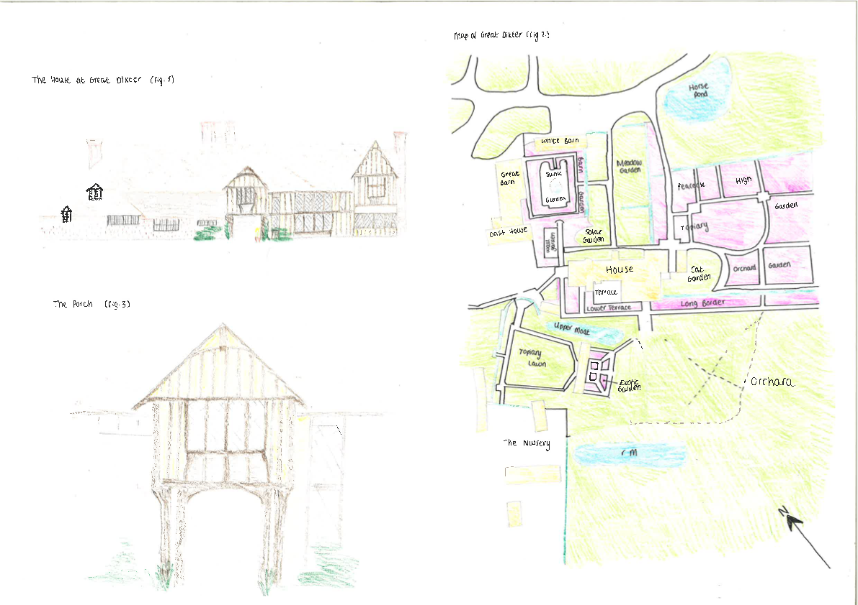

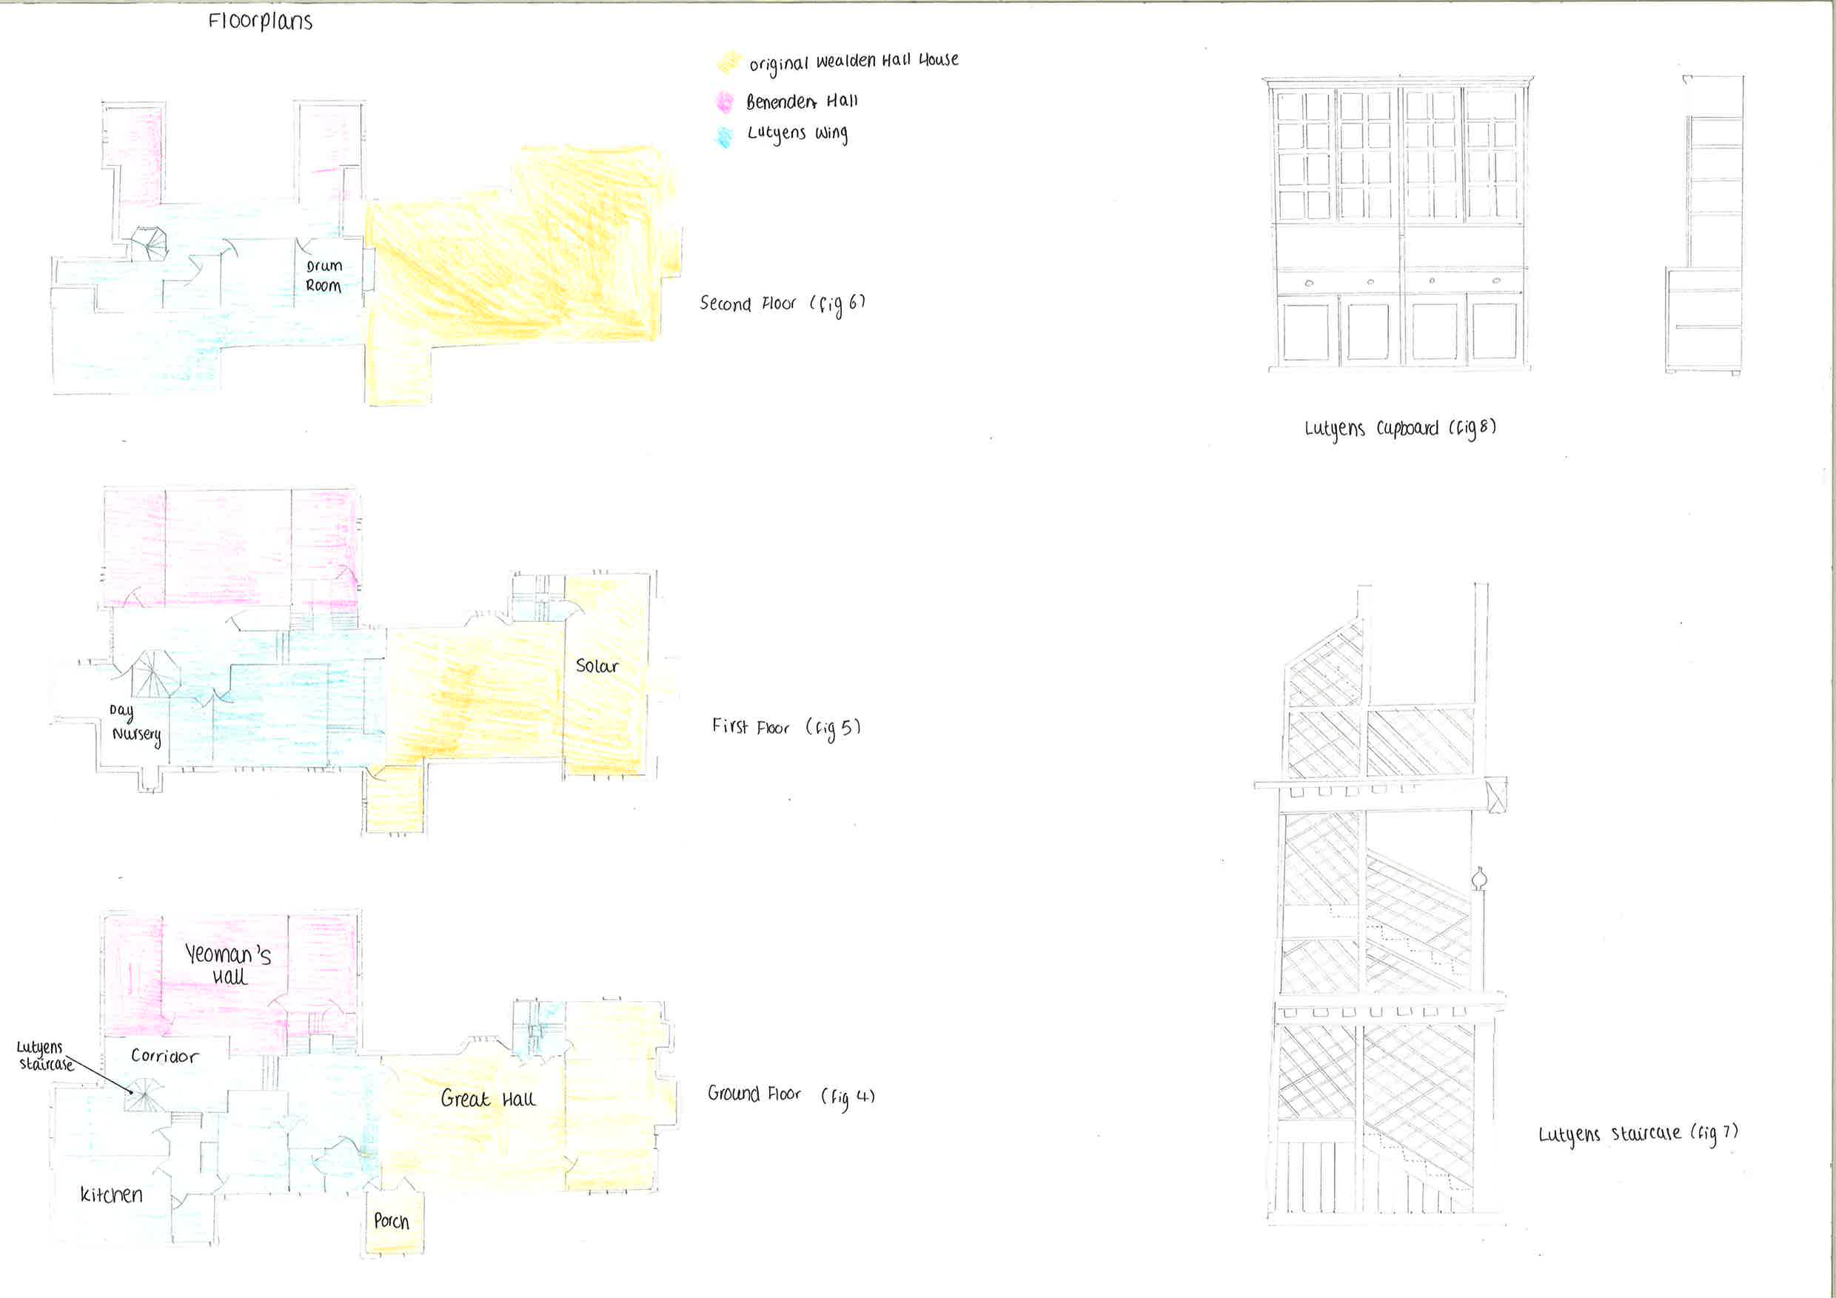

A Guide to Great Dixter, Charles Hind, 2015, page 2
A Guide to Great Dixter, ‘Gardening in the spirit of Christopher Lloyd’, 2015, page 36
A Guide to Great Dixter, Tony Lord, 2015, page 28
A Guide to Great Dixter, Tony Lord, 2015, page 30
Stamp, Gavin Memorial to the Missing of the Somme, 2007, page 20
A Guide to Great Dixter, Charles Hind, 2015, page 14
A Guide to Great Dixter, Charles Hind, 2015, page 14
Hind, C. A Guide to Great Dixter, 2015, page 20
A Guide to Great Dixter, Vegetable Gardening, 2015, page 50
Thaler, R.H. and Sunstein, C.R. Nudge: Improving Decisions about Health, Wealth and Happiness. 2008
Koeper, H.F. https://www.britannica.com/biography/Louis-Sullivan , 2016

