Question 3- Chemical reactions for making antibodies: What does the future hold?

The high specificity of antibodies for a particular antigen means they can be used in a range of applications, beyond their natural role in the immune system. Antibodies are immunoglobulins and in humans there are five classes: IgM, IgA, IgG, IgE and IgD, with IgG being the most abundant.
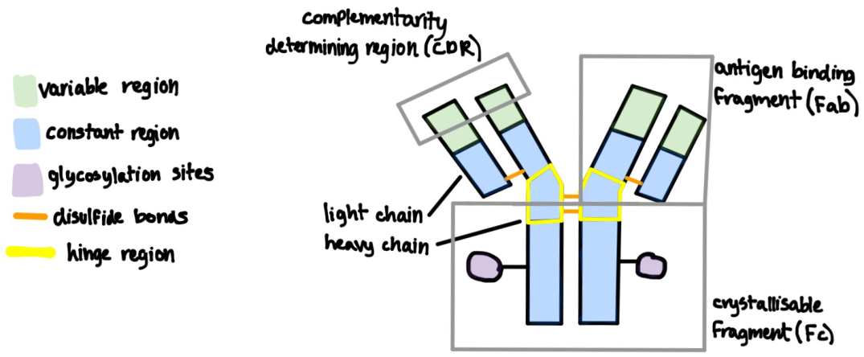
Figure 1- structure of an IgG

All antibody classes have a common Y-shaped structure, similar to the IgG structure, consisting of two heavy (μ, α, γ, ε or δ) and two light, (κ or λ) polypeptide chains, the heavy chains are glycosylated in the constant regions. The Fc is responsible for activating antibody dependent cell mediated cytoxicity and complement mediated cytotoxicity by binding to receptors on the complement or effector cells. The Fabs are responsible for binding to its complementary antigen.₁ Each heavy chain consists of over 400 amino acids and each light chain consists of over 200₂, hence the high variability of antibodies, each with a different specificity resulting from different sequences of these amino acids.
During an immune response, several different B cells proliferate and differentiate into antibody secreting plasma cells, each producing antibodies complementary to different epitopes on the same antigen. Therefore the antibodies found in the blood are polyclonal as they are formed from different cell lines. Monoclonal antibodies, which are derived from the same parent cell so that they all target the same epitope, in contrast, must be made in vitro.₃ Although the production process of these is complex, monoclonal antibodies are useful as the fact each one in a batch targets only one specific epitope means they are less likely to bind to other molecules, whereas polyclonal antibodies bind with several epitopes, one of which is likely to also to appear on molecules other than the original antigen, which would decrease the effectiveness of the antibodies.
Monoclonal antibodies have a variety of uses: they form the basis of many in vitro diagnostic tests such as ELISAs or pregnancy tests, as well as in vivo diagnostics for imaging of diseases such as by joining them to a radioactive isotope; they are used to purify proteins, and they are used in therapeutics, on their own as direct therapeutic agents to elicit effector functions or block receptors, or as targeting therapeutic agents joined to a cytotoxic molecule₄. Monoclonal antibodies have many significant current and potential future successes, but when they are used, particularly in vivo, many problems must first be overcome, by altering the production process or by modifying them after they have been produced.

Production of Monoclonal Antibodies:
Monoclonal antibodies were initially produced by Milstein and Koehler in 1975. The production of these monoclonal antibodies was done by injecting an antigen into a mouse and then by extracting an antibody producing spleen cell from the mouse and fusing it with with a myeloma cell, to produce a hybridoma. A hybridoma has the rapid cell division ability of the the myeloma cell to produce a large number of clones, as well as the antibody secreting function of the spleen cell, therefore meaning many monoclonal antibodies can be produced from one cell line.₅
However, monoclonal antibodies derived by hybridoma technology have a very short half life as they are murine antibodies and therefore have high immunogenicity in the human body.₆ This means they are often unable to trigger effector functions as they do not last long enough in the body. However, this problem can be reduced by humanising the antibodies. Initially, they were modified into chimeric antibodies which have the constant regions of a human antibody, but the variable regions of a murine antibody. Later, even less immunogenic antibodies were created, called humanised antibodies, with only the complementarity determining regions from the murine antibody being combined with the framework of the human variable and constant regions.₇ Fully human monoclonal antibodies can also be made rather than murine ones using hybridoma technology, via the use of transgenic mice to produce human antibodies, hence minimising immunogenicity.₈ However, the use of transgenic animals may be considered unethical and can be expensive.
More recently, a new way to produce monoclonal antibodies has been developed due to advancements in genetic engineering, by display methods, predominantly phage display. This method allows not only full antibodies to be produced but also fragments of antibodies to be produced. The genes for the antibody or part of the antibody are spliced into the protein coat genes of the bacteriophage, a virus, so that the desired protein is displayed on the surface of the phage. A library of these antibody presenting phages can be built up, each one with slightly different amino acid sequences. The antibody phage with the greatest affinity for a particular antigen is then selected and uses a bacteria as a host, which causes the virus to replicate. The antibody genes can then be extracted from the phage and used to make many genetically identical antibodies._{9,10,11}
Phage display technology does have difficulties, it is hard to express whole human antibodies in the phage as the antibodies produced may not develop the correct complex folding in the polypeptide chain. Therefore, most approved whole antibodies for commercial use are still made by hybridoma technology.₈ The antibodies produced are also not glycosylated as the phage lack all the enzymes required for glycosylation, meaning they bind much less easily to Fc receptors on immune cells and the complements so can not activate effector functions. This means antibodies produced by phage display are more likely to be used for targeting in therapeutics as opposed to acting directly, or will be fragments of antibodies which do not have glycosylation sites and which have less complex folding.₁₂

Modifying monoclonal antibodies- altering the Fc region:
Although not involved in binding to the antigen, the Fc significantly impacts the effector functions as it is responsible for binding to Fc receptors on effector cells and the complement. In antibodies produced by hybridomas, the oligosaccharide at the glycosylation sites can be changed to improve the binding between the antibody and the Fc receptor, or can be removed to reduce binding with the Fc receptor when not required if they are used as targeting therapeutic agents, such as antibody-drug conjugates, which work without the need of effector functions. In human IgGs, an oligosaccharide is attached to the asparagine residue, which is 297 along the amino acid sequence₁₃, on each heavy chain by a glycosidic bond to acetylglucosamine. This one can be hydrolysed by glycosidases to remove the oligosaccharide from each heavy chain₁₄.The antibody can then be left like this or another oligosaccharide can be joined to the asparagine residue, depending on the use of the antibody. In antibodies produced by phage display which are not glycosylated, an oligosaccharide may be attached to the 297 asparagine residue if the antibody is being used as a direct agent in therapeutics.
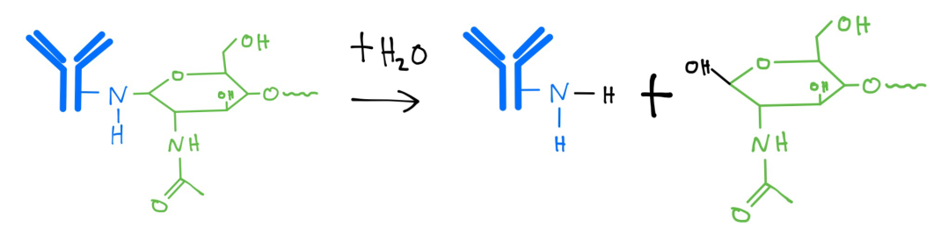
Figure 2- hydrolysis of a glycosidic bond between the asparagine residue and acetylglucosamine at the start of the oligosaccharide on one side of the IgG.

Modifying monoclonal antibodies- antibody fragmentation:
In many situations, not a whole antibody, but only the variable regions are required. For example: when they are only needed to be small in order to block a signalling receptor on an antigen; to eliminate the non-specific binding of the Fc region with Fc receptors on cells; when a whole antibody is too large to reach the inside cells in a tumour₁₅, or when the short half life of an antibody fragment is desired- such as if it has been joined to a radioactive isotope, to reduce radioactive exposure time for the person₁₆. The antibody can be fragmented through the enzymatic method of proteolysis. The two main enzymes used are: papain and pepsin. Papain is used to separate the Fabs and the Fc in an IgG by catalysing the breaking of peptide bonds above the disulfide bonds in the hinge region, but below the disulfide bonds joining the light and heavy chains together. Whereas pepsin is used to separate most of the Fc region from the two Fabs and some of the hinge region binding them together_{17,18}. Both enzymes catalyse the hydrolysis of peptide bonds between amino acids in the antibodies but pepsin requires a more acidic pH to work optimally.
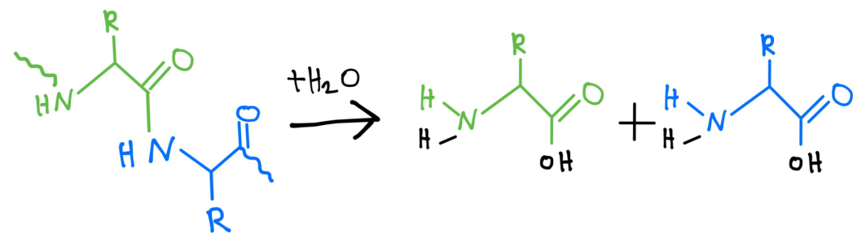
Figure 3- hydrolysis of a peptide bond between any two amino acids in the antibody, with the assistance of pepsin or papain.
Antibody fragments are also easier to make than whole antibodies through phage display as fewer genes are required, only 3 are currently approved for commercial use, but
more are being developed. An example is certolizumab pegol, a Fab bound to two polyethene glycol molecules. This blocks receptors on the protein, tumour necrosis factor, reducing inflammation in treatment of diseases such as arthritis₁₉.

Alternative antibody formats- Bispecific monoclonal antibodies:
Bispecific antibodies have been created in which each Fab on the antibody has a different specificity₂₀. One Fab may bind to an antigen whilst the other to an effector cell, and bring the two into close contact, enhancing the effector function on the antigen. Alternatively each Fab may bind to a different antigen both expressed on the same pathogen or abnormal cell, increasing the likelihood of the antibody binding to the antigen.
They can be produced by fusing two hybridomas to form a quadroma which secretes antibodies with one antigen binding site from each parent cell. However only a small proportion of the antibodies are like this due to the random possible combinations of the heavy and light chains from each hybridoma₂₁. DNA recombinant technology methods and phage display are therefore preferred to make bispecific antibodies to avoid this problem, such as the 'knobs into holes' method. The genes are altered in one heavy chain of two different antibodies so that one has a 'knob' shape, and the other has a complementary 'hole' shape so they can bind to each other to form a whole bispecific antibody₂₁. An example of an antibody made in this way is onartuzumab which is currently in clinical trials. This antibody targets the hepatocyte growth factor receptor, commonly expressed on tumour cells, particularly in the lungs and therefore causes the death of these cells- so it is hoped it will be able to be used in the treatment of lung cancer₂₂.

Alternative antibody formats- Antibody-cytotoxic agent conjugates:
Monoclonal antibodies have been modified to create antibody-drug conjugates, this allows abnormal or infected cells and pathogens to be targeted more specifically which also means fewer healthy cells are harmed than if the drug was issued on its own. Furthermore, often more than one molecule of the drug can be attached to each antibody by different amino acid residues on the surface of the antibody, increasing the cytoxicity of each antibody further. Linkers are typically attached to lysine or cysteine residues present on the surface of the antibody due to their side chains which can bond with other molecules₂₃.
One example of this includes: inotuzumab ozogamicin. This is being trialled in the hope it will be used to treat lymphoblastic leukaemia. The antibody is joined to the drug calicheamicin by a 4-(4-acetylphenoxy)butanoic linkage in which the amine group on a lysine amino acid residue is condensed to bind to the carboxyl group of the linker, which in turn forms a hydrazone bond with calicheamicin. After binding to the CD22 epitope on the cancer cell, the antibody-drug conjugate is taken into the cell by endocytosis at which point the acidic conditions cause the hydrazone bond to be hydrolysed, releasing the drug and allowing it to carry out its function₂₄.
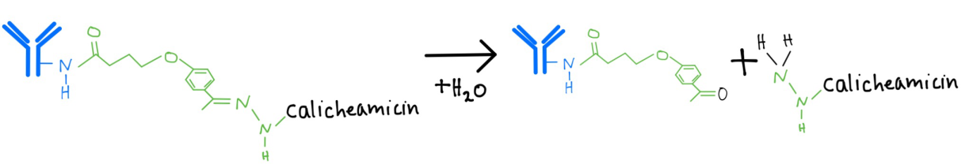
Figure 4- hydrolysis of a hydrazone bond in the 4-(4-acetylphenoxy)butanoic linker, which separates the antibody from the drug, calicheamicin
Similarly, antibodies can be tagged with a radioactive isotope, which localises the cytotoxic radioactive effect. These can be used in cancer therapy, an example of which is I¹³¹-tositumomab. To form this particular conjugate, a tyrosine residue on the antibody undergoes electrophilic substitution of a hydrogen on its phenolic ring with the iodine¹³¹ isotope. This targets the epitope CD20, present on healthy and cancerous B-cells. The method of joining the radioactive isotope and antibody varies with the specific antibody and isotope used_{25,26}. Radioactively labelled antibodies are also used in imaging of tumours, as the areas of high emitted radiation can be detected, signifying where the antibodies have bound to tumour cells, thus allowing the patient to be given suitable treatment.
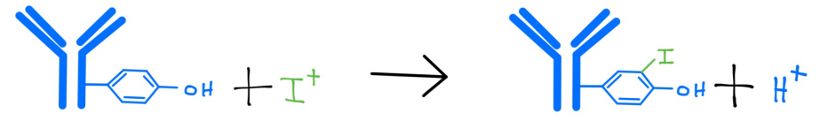
Figure 5- substitution reaction of a hydrogen atom on a tyrosine residue with a I¹³¹ isotope.

Antibody mimics:
An alternative to monoclonal antibodies is antibody mimics which are created by molecular imprinting. The first step in molecular imprinting is self assembly in which free monomers in solution join to the desired antigen, which acts as a template. The next step is polymerisation involving cross linkers to join the attached monomers around the template. Then the template is extracted by hydrolysis, leaving the newly formed polymer with a cavity containing a complementary recognition site to the target molecule, thus creating a polymer with a high specificity, similar to that of antibodies_{27,28}.
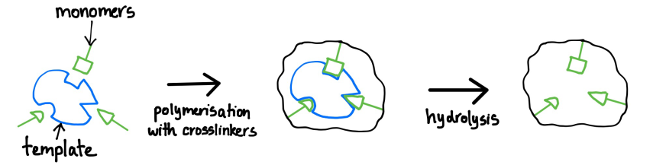
Figure 6- the basic principle of molecular imprinting

The advantages of using artificial antibodies, includes that they are smaller than whole antibodies so if used in therapeutics, similarly to antibody fragments, they can reach areas which antibodies can not and they can be made to target molecules for which no antibodies exist. They are currently used in vitro in diagnostics, however use of these in vivo for humans has not yet been explored due to concerns over their immunogenicity. However, in 2010, the first molecularly imprinted antibody mimic was successfully used in mice against the target molecule, melittin, a toxin present in bee venom, giving promise for future use in humans₂₉.

It has been over 100 years since antibodies were described as 'magic bullets'₃₀, before many of their applications were even known and before monoclonal antibodies had even been produced, undoubtedly there are still more applications to be discovered. From whole monoclonal antibodies to antibody mimics, the progress of their use in therapeutics, particularly for treating cancerous tumours, has been highly successful, with 47 therapeutic monoclonal antibody products approved for commercial use as of November 2014 and many more are used for non-therapeutic purposes₃₁, Perhaps in the future, new recombinant antibodies or antibody mimics will be made for antigens for which no natural antibodies exist at all, for example, they could be used if a pandemic occurs of a rare disease, new disease or new strain of disease, in which the pathogens have antigens for which humans have not yet developed natural antibodies for.

Bibliography:
1. Immunoglobulins- structure and function, http://www.microbiologybook.org/mobile/m.immuno-4.html, accessed 18/02/17
2. Antibody structure and isotypes, http://www.abcam.com/protocols/antibody-structure-and-isotypes, accessed 18/02/17
3. A comparison between polyclonal and monoclonal, http://www.abcam.com/protocols/a-comparison-between-polyclonal-and-monoclonal, accessed 17/02/17

4. Applications of Monoclonal Antibodies: 4 Applications, http://www.biologydiscussion.com/biotechnology/applications-of-monoclonal-antibodies-4-applications/10045, accessed 18/02/17
5. Mary and Geoff Jones (1997), Advanced Biology, page 494, accessed 14/02/17
6. Humanised antibodies, http://crdd.osdd.net/raghava/absource/humanized.html, accessed 16/02/17
7. Humanising, http://absoluteantibody.com/antibody-resources/antibody-engineering/humanisation/, accessed 16/02/17
8. Richard Buick (2016), Why is antibody humanisation still important in the 21st century?, https://www.fusionantibodies.com/blog/2016/january/ebr-antibody-humanization-article, accessed 16/02/17
9. Charlie Abbot (2014), Phage Display, https://youtu.be/AqQDZxoCGqE, accessed 14/02/17
10. Phage Display & Antibody Library Services, http://www.creative-biolabs.com/phage-display-service.html?gclid=CKzKufyuktICFe-_7QodMTMNag, accessed 14/02/17
11. Recombinant antibodies (rAbs) produced without the use of animals, http://altweb.jhsph.edu/mabs/rabs.html, accessed 14/02/17
12. André Frenzel, Michael Hust, and Thomas Schirrmann, Expressing Recombinant Antibodies, https://www.ncbi.nlm.nih.gov/pmc/articles/PMC3725456/#!po=33.9080, page 29-30, accessed 14/02/17
13. Sonja Schneider, http://www.agilent.com/cs/library/applications/5990-9774EN.pdf, accessed 16/02/17
14. Protein Glycosylation, https://www.thermofisher.com/uk/en/home/life-science/protein-biology/protein-biology-learning-center/protein-biology-resource-library/pierce-protein-methods/protein-glycosylation.html#, accessed 16/02/17
15. Advantages Of immunoglobulin F(ab) and F(ab')2 fragments, http://www.abcam.com/secondary-antibodies/advantages-of-immunoglobulin-fab-and-fab2-fragments, accessed 15/02/17
16. Antibody fragments, http://absoluteantibody.com/antibody-resources/antibody-engineering/antibody-fragments/, accessed 15/02/17
17. Antibody fragmentation, https://www.thermofisher.com/uk/en/home/life-science/antibodies/antibodies-learning-center/antibodies-resource-library/antibody-methods/antibody-fragmentation.html, accessed 15/02/17
18. Proteolytic antibody fragmentation, http://www.sigmaaldrich.com/life-science/biochemicals/biochemical-products.html?TablePage=109985567, accessed 15/02/17
19. What is certolizumab pegol and why is it prescribed?, http://www.arthritisresearchuk.org/arthritis-information/drugs/certolizumab-pegol/what-it-is.aspx, accessed 15/02/17
20. Generation of bispecific antibody, http://www.creativebiolabs.net/generation-of-bispecific-antibody.htm?gclid=CJPP0YWyrtICFWYq0wodMcwMwg, accessed 17/02/17
21. Ivana Spasevska (2013), An outlook on bispecific antibodies: Methods of production and therapeutic benefits, http://biologie.ens-lyon.fr/ressources/bibliographies/pdf/m1-12-13-biosci-reviews-spasevska-i-2c-m.pdf?lang=fr, accessed 17/02/17
22. NCI Drug Dictionary, https://www.cancer.gov/publications/dictionaries/cancer-drug?cdrid=639516, accessed 17/02/17
23. Bruce Tomczuk (March 2015), Current ADC linker chemistry, https://www.researchgate.net/profile/Bruce_Tomczuk4/publication/273438032_Current_ADC_linker_chemistry/links/55006e240cf2aee14b548eb0/Current-ADC-linker-chemistry.pdf, accessed 15/02/17
24. Hervé BouchardChristian ViskovCarlos Garcia-Echeverria (2014), Antibody–drug conjugates—A new wave of cancer drugs, http://www.sciencedirect.com/science/article/pii/S0960894X1401066X, accessed 15/02/17
25. Grant Sugiura, Helen Kühn, Max Sauter, Uwe Haberkorn and Walter Mier (2014), Radiolabeling Strategies for Tumor-Targeting Proteinaceous Drugs, http://www.mdpi.com/1420-3049/19/2/2135/pdf, chapter 6, accessed 15/02/17
26. Martina Steiner and Dario Neri (2011), Antibody-Radionuclide Conjugates for Cancer Therapy: Historical Considerations and New Trends, http://clincancerres.aacrjournals.org/content/17/20/6406, accessed 15/02/17
27. Molecular imprinting, https://www.ifm.liu.se/edu/coursescms/tftb34/archive/Molecular_imprinting_OH.pdf, accessed 17/02/17
28. (2001), Molecular imprinting, http://www1.chem.leeds.ac.uk/People/RJA/molimp.html, accessed 17/02/17
29. Andy Coghlan (2010), World’s first plastic antibody works in mice, https://www.newscientist.com/article/dn19031-worlds-first-plastic-antibody-works-in-mice/, accessed 17/02/17
30. (2015), Paul Ehrlich, https://www.chemheritage.org/historical-profile/paul-ehrlich, accessed 21/02/17
31. Dawn M Ecker, Susan Dana Jones, and Howard L Levine (2015), The therapeutic monoclonal antibody market, https://www.ncbi.nlm.nih.gov/pmc/articles/PMC4622599/, page 1, accessed 18/02/17

