Newnham Engineering Prize 2017 Question 2c Tamilore Ayo-Famola

The ‘hyperloop’ –will it help solve our transport problems?

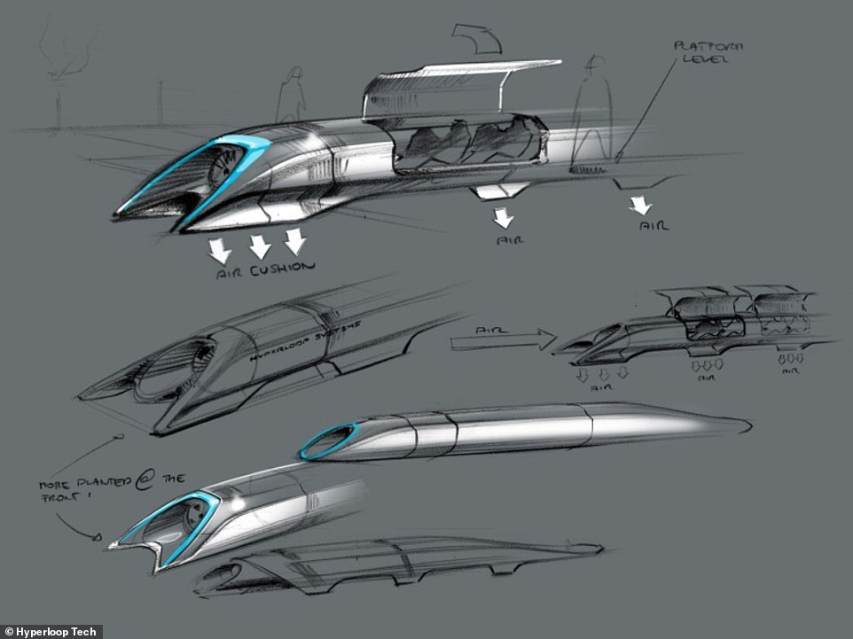
Hyperloop concept from SpaceX Alpha paper

The Hyperloop is a mode of passenger and freight transportation, proposed by Elon Musk in 2013, that would propel a pod-like vehicle through a near-vacuum, low pressure tube at more than airline speed. The goal of the hyperloop is to improve upon the current systems of transportation available today, including air, water, rail and road travel, to be as fast as an airplane but as convenient and accessible as a train. It is without a doubt that there is a need for transportation, which is essential for the development of civilisations by enabling interaction and trade between people, however by 2050 the UN’s DESA Population Division predicted the worlds population will reach an estimate of 9.7 billion people, 66% of which will be living in urban areas. Unless there is a change, the result of this population growth will be considerable strain on cities’ existing transport infrastructure. An effective solution would have to be cheaper, more efficient and faster than any other established mode of transportation. The Hyperloop isn't the only solution to this issue, neither is it the first of this sort of concept and although its manifestation could be groundbreaking it may not be able to solve our transport problems.

The concept of high-speed travel in tubes has been around for decades. For example, the atmospheric railway which uses differential air pressure to provide power for propulsion of a railway vehicle. A static power source can transmit motive power to the vehicle in this way, avoiding the necessity of carrying mobile power generating equipment. Several variants of the principle were proposed in the early 19th century, and a number of practical forms were implemented, but all were overcome with unforeseen disadvantages and discontinued within a few years. Trains often overshot the platform as air railway brakes proved extremely difficult.Communication was required between the stations and the pumping houses so that the pumps could start evacuating the pipe in advance of the train leaving. It was not possible to use the pipe where lines diverged or met such as points and junctions.

Another proposed vacuum train is the California High Speed Rail, a system currently under construction in the U.S state of California. It is designed to travel between California and San Francisco with speeds up to 350 km/h, completing the trip in 2 hours and 40 minutes. The California High Speed Rail is expected to reduce the distance traveled, improve air quality, and reduce greenhouse gases. The high speed rail is significantly faster than traveling by car but still slower than traveling by plane. Moreover, the cost of construction is estimated at $68 billion and an average ticket will cost $80 to $90. Unfortunately, the project is currently 50% below the necessary funds for completion by 2028. Assuming all estimates are correct, the costs of the California High Speed Rail make the project a great financial burden. Some have suggested that instead of risking the large expenditures of high-speed rail, existing transportation methods be improved and enlarged to meet increased transportation needs. However, in a report commissioned by the California High-Speed Rail Authority, a comparison was made to the needed infrastructure improvements if the high-speed rail is not constructed. According to the report, the cost of building to an equivalent sufficiency in airports and freeways is estimated to be $119 billion for 4,295 miles (6,912 km) of highway, plus $38.6 billion for 115 new airport gates and 4 new runways –a total estimated cost of $158 billion. A new form of transportation is therefore, economically, the best option for solving our transportation problems.

Alternatively, Musk’s Hyperloop system could cover the distance between Los Angeles and San Francisco in 35 minutes and cost a mere $20 per ride. With regards to construction, Musk believes that the whole system will cost between $6 billion and $7.5 billion. His $6 billion estimate is for two one way tubes and 40 capsules with no cargo space, while the higher end of the estimate would carry cargo. However some critiques of the Hyperloop stems from doubts about the technology and the project's economics. For instance, the proposal briefly discusses the issue of thermal expansion. Most railways leave gaps between tracks to accommodate the expanding metal. In high-speed railways, rails are allowed to overlap at the ends and in some piping systems, the expansion is dealt with by adding expansion loops placed at appropriate intervals. None of these methods is possible for the Hyperloop because the high speed of the capsule zooming along inside it means the pipe curves have to be very gentle therefore Musk’s solution is for “specially designed slip joints at stations will be able to take any tube length variance due to thermal expansion. This is an ideal location for the thermal expansion joints as the speed is much lower nearby the stations. It thus allows the tube to be smooth and welded along the high speed gliding middle section.” Nevertheless mathematical calculations by Dr. Drank, leancrew.com, show that this is an impractical approach as the system’s 300 mile pipe would vary in length, due to thermal expansion and contraction, by 1030ft which cannot possibly be supported by the track.
Moreover, James Moore, director of the University of Southern California’s Transportation Engineering Program, raises concerns about the comfort of passengers saying, “Whether such a system can provide a comfortable, humanly bearable ride is completely unclear.”
Also many believe the expected costs are drastically underestimated with the entire project forecasted closer to $100 billion by Michael L. Anderson, an associate professor of agricultural and resource economics at the University of California, Berkeley. Another point of debate is that the route proposed doesn't meet the needs of providing statewide transportation, and it does not meet the legal requirements of Proposition 1A and so would require a whole new legal underpinning. Thus, compared to the California High Speed Rail, the Hyperloop concept proposed by Elon Musk is less likely to solve our transportation problems as it involves untested and seemingly inadequate technology as well as a myriad of legal and economic challenges before it can be implemented. Based of Musks Hyperloop design and monetary estimations, the likelihood that he will fulfil his vision of the Hyperloop as “the fifth mode of transportation”is very slim.

Despite these complications, the Hyperloop concept has been explicitly open sourced by Elon Musk and SpaceX, and others have been encouraged to take the ideas and further develop them. The plans were picked up by two companies Hyperloop Transportation Technologies (HTT) and Hyperloop One, and several interdisciplinary student-led teams are working to advance the technology. Most of the active Hyperloop routes being planned currently are outside of the U.S. Hyperloop One published the world's first detailed business case for a 300-mile (500 km) route between Helsinki and Stockholm, which would tunnel under the Baltic Sea to connect the two capitals in under 30 minutes. The company is also well underway on a feasibility study with DP World to move containers from its port of Jebel Ali in Dubai. Others have put forward European routes, including a Paris to Amsterdam route proposed by Delft Hyperloop. No work has been done on the route proposed in Musk's alpha-design as it would terminate on the fringes of the two major metropolitan areas, Los Angeles and San Francisco, resulting in significant cost savings in construction, but requiring that passengers traveling to and from Downtown Los Angeles and San Francisco, and any other community beyond Sylmar and Hayward, to transfer to another transportation mode in order to reach their final destination. This would significantly lengthen the total travel time to those destinations.

Recently, As well as taking the overall prize, TU Delft received the award for the best construction and design at SpaceX’s Hyperloop Pod Competition. This latest phase finally saw student teams testing their designs out on SpaceX’s 1.2km test track, built just outside the company’s headquarters in Hawthorne, California. TU Delft made use of an aerodynamic, carbon fibre shell to create a 4.5m long, 1m high pod weighing just 149kg. The low weight will allow for a smaller engine and less massive tracking than a heavier vessel would.During the competition, the pod recorded speeds of 90km/h, but the team claims the prototype could reach and withstand speeds up to 1,200km/h on a longer track.
The Halbach array is a special configuration of permanent magnets that allow the pod to hover just above the track by generating a strong, repulsive magnetic field on one side of the magnet while cancelling the field to near zero on the other side. The side with the strong magnetic field faces the track creating a passive, fail-safe electro-dynamic suspension (EDS) system when the magnets are above a conducting material (aluminium) meaning high speeds can be achieved with relatively little energy.

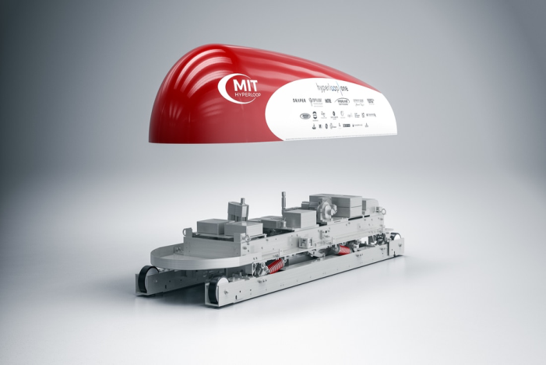
The Hyperloop prototype by the Massachusetts Institute of Technology which is of a similar design, uses eddy currents created by the magnetic field parallel to the aluminium track as a braking mechanism. An eddy current is a swirling current set up in a conductor in response to a changing magnetic field. By Lenz's law, the current swirls in such a way as to create a magnetic field opposing the change. Due to the tendency of eddy currents to oppose, eddy currents transform more useful forms of energy, such as kinetic energy, into heat, which is generally less useful. In many applications the loss of useful energy is not particularly desirable, but there are some practical applications. During braking, the metal wheels are exposed to a magnetic field from an electromagnet, generating eddy currents in the wheels. The magnetic interaction between the applied field and the eddy currents acts to slow the wheels down. The faster the wheels are spinning, the stronger the effect, meaning that as the train slows the braking force is reduced, producing a smooth stopping motion. Maglev trains move more smoothly and more quietly than wheeled mass transit systems. The power needed for levitation is typically not a large percentage of its overall energy consumption; most goes to overcome drag, as with other high-speed transport.
Compared to conventional trains, differences in construction affect the economics of maglev trains, making them much more efficient. For high-speed trains with wheels, wear and tear from friction from wheels on rails accelerates equipment wear and prevents high speeds. Conversely, maglev systems have been much more expensive to construct, offsetting lower maintenance costs.
MIT Hyperloop pod design

Despite decades of research and development, maglev transport systems are in operation in just three countries (Japan, Korea and China).

The fact that this technology has been used before creates more confidence in the feasibility of the Hyperloop, especially as the prototype have been shown to perform well at the SpaceX competition although not yet to full capacity. Furthermore, the limited number of maglev trains in use means that the Hyperloop can still be regarded as a new and innovative idea. If electrodynamic suspension is used rather than Musks air skis then the Hyperloop has greater chances of becoming a successful mode of transportation.
Moreover, the hype created by the competition has presented a large number of people who believe the Hyperloop is worthwhile such as the 113 teams that originally entered the competition and the company's sponsoring and funding the teams. In addition, comparing the Hyperloop models which have been tested and made it to the final stages of the competition along side the two existing modes of transportation, air and rail, the hyperloop is able to hold its own. If TU Delft’s hyperloop can truly reach speeds around 1200km/h it would be faster than any plane travelling at 1000km/h and much more so than trains, including high speed ones, travelling at a mere 350km/h. Also this particular model boasts of consuming just 60kWh of clean, carbon-free energy whereas planes and trains consume 33,000 kWh and 16,500kWh of energy respectively, making the Hyperloop superior in its efficiency and eco-friendliness. In the case of freight transportation, the Hyperloop is at a disadvantage because increasing speed is not what the industry wants or needs.
Successful freight rail companies, for example the Class I railroads in North America, China Railways, and Russian Railways, make money off of carrying goods over very long distances at low cost. Quite often this is because the goods in question is so heavy that even without substantial fuel taxes, trucks cannot compete on fuel or on labor costs; this is why Western Europe’s highest freight rail mode share is found in Sweden, with its heavy iron ore trains, and in Switzerland long-distance freight across the Alps or toward Russia. It's for this reason that previous endeavours into fast freight services have not been successful and why it is likely that the Hyperloop will have similar success. The Hyperloop generally could only operate as a passenger transport with tubes carrying 3,360 passengers each hour, a single tube would be able to transport 7.4 million people per year. Nevertheless, comparatively, a freeway lane can carry 2,000 cars per hour, a subway transports 36,000 passengers per hour, and the California High Speed Rail is estimated to carry 12,000 passengers per hour. Despite this, the Hyperloop could make a considerable impact in passenger transport if fully and efficiently implemented while working alongside other modes of transportation.

An alternative solution to be considered could be smart technology or Intelligent transportation systems (ITS) which are advanced applications which, without embodying intelligence as such, aim to provide innovative services relating to different modes of transport and traffic management and enable various users to be better informed and make safer, more coordinated, and 'smarter' use of transport networks. With research labs in Africa and Australia and areas of interest such as predicting traffic flow and passenger and freight transport, ITS can be used to improve upon existing modes of transportation without the costs of expanding current infrastructure.

In conclusion, the concept of the Hyperloop is pushing boundaries of speed and efficiency which are necessary aspects in renovating transport. However, practically it has many obstacles to overcome before it can make any worthwhile impact and part of its appeal maybe it's utopian, futuristic feel rather than its technological and socio-economic consequent on our transport system. The Hyperloop may be successful in the future, although much later than the anticipated 2020, but at the moment other alternatives to the Hyperloop should be considered as solutions to our transport problems.

Bibliography
- Hyperloop or over-hyped? Latest demo does little to ease doubts

[ https://www.theguardian.com/technology/2016/may/12/hyperloop-or-over-hyped-latest-demo-does-little-to-ease-doubts]
- http://www.catc.ca.gov/programs/hsptbp.htm
- Hyperloop and our misplaced love of futuristic technology

[ https://www.theguardian.com/sustainable-business/2016/aug/14/hyperloop-elon-musk-futuristic-technology-transport]
- Eddy currents and brakes

[ http://www.physlink.com/education/askexperts/ae527.cfm]
- How MagLev trains work

[ http://science.howstuffworks.com/transport/engines-equipment/maglev-train.htm]
- The Hyperloop might not work for shipping, either

[ http://science.howstuffworks.com/transport/engines-equipment/maglev-train.htm]
- Hyperloop system vs High Speed train: What’s best for California (TSLA)

[ http://www.investopedia.com/articles/investing/050815/elon-musks-hyperloop-economically-feasible.asp]
- Delft Hyperloop

[ http://indg.com/hyperloop/#m=intro]

[ http://delfthyperloop.nl/#intro]
- MIT Hyperloop

[ http://www.mithyperloop.org]
- Hyperloop Alpha Paper

[http://www.spacex.com/sites/spacex/files/hyperloop_alpha.pdf]

Hyperloop and our

