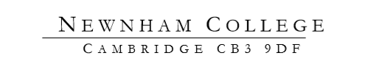
Booking Form
Event

Date

Name

Address

Entitlement

Dietary Requirements

Wine | YES | NO
Guests 1:

Dietary Requirements

Wine | YES | NO
Guests 2:

Dietary Requirements

Wine

Guests 3:

Dietary Requirements

Wine | YES | NO

